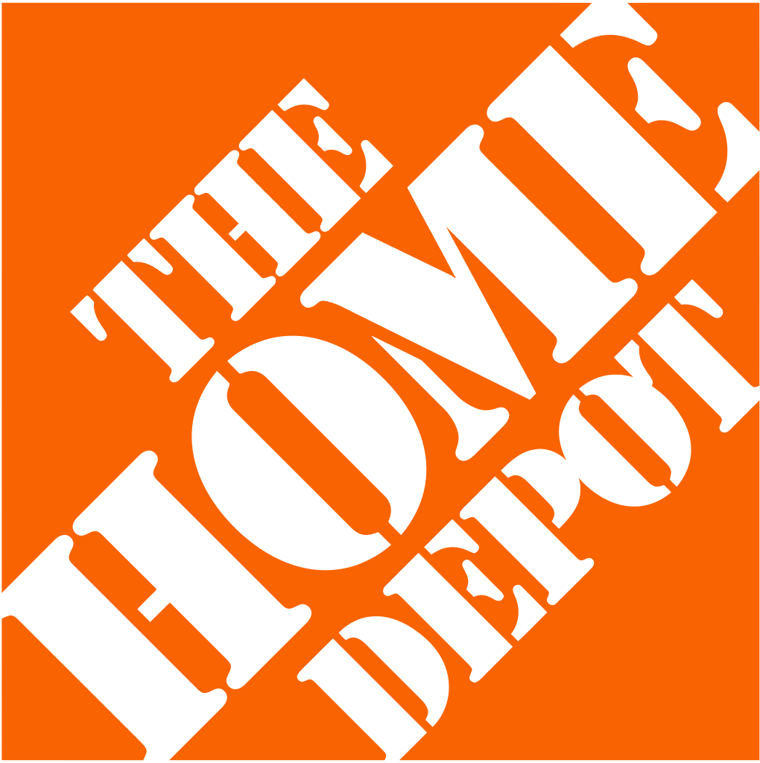

**Live Case Study**

**Professor Abukari**

**BUSI 3500B**

**November 30, 2022**

Allisha Lin - 101167939

Liam Cabral - 101142034

Risonn Ibbrahim Kumaaraa - 100910277

Ben Wolkowycki - 101134026

Khash Zarekarizi - 101162737

**Table of Contents**

**I. Corporate Governance Analysis ............................................................................. 03**

**II. Stockholder Analysis ............................................................................ 04**

**III. Risk and Return ............................................................................. 05**

**IV. Measuring Investment Returns ............................................................................. 12**

**V. Capital Structure Choices .............................................................................15**

**VI. Optimal Capital Structure ..............................................................................21**

**VII. Moving to the Optimal Structure ............................................................................. 23**

**VIII. Dividend Policy .............................................................................. 25**

**IX. Valuation ...............................................................................27**

**X. Possible Restructuring .............................................................................. 29**

**Appendices .............................................................................. 31**

**I. Corporate Governance Analysis**

**I.I - CEO & Board of Directors**

The CEO of the firm is Edward P. Decker. Mr. Decker has served as CEO and President of Home Depot since March 2022.[1] Prior to this, Mr. Decker served as President and Chief Operating Officer between October 2020 and February 2022. From August 2014 to October 2020, he was the Executive Vice President for Merchandising. He was also Senior Vice President – Retail Finance, Pricing Analytics, and Assortment Planning. Mr. Decker came from inside the organization, having been with the company since 2000. CEO compensation for the current CEO is not officially available, possibly due to him being new to the role. As of September 21, 2020, the former CEO Craig Menear received a total compensation of US$11 million, comprising US$1.3 million in salary and other compensation (including stock compensation) of US$9.6 million.[2] As of March 22, 2022, the current CEO, Mr. Decker, owns a total of 94,831 shares which at the time of this writing is valued at just over US$27.182 million. This implies that Mr. Decker’s interests are well-aligned with those of the shareholders and the success of the firm.

The Home Depot, Inc. board of directors consists of 13 members with the only insider being the President, Chair and CEO Edward P. Decker (Appendix 1). As shown in Appendix 1, the tenures of the board members vary. While the multiple positions of Mr. Decker have the potential to cause corporate governance issues, it appears that this has a limited effect on the creation of stockholder value. The firm has a strong history of providing value to shareholders throughout the years. While all members of the board of directors have executive experience, 6 of them are currently CEOs for different companies. Compared to the market capitalization of the firm, none of the board members own a significant percentage of stock in the firm or represent those who do.

According to Home Depot, “Corporate governance is part of [their] culture and is founded on [their] daily commitment to living values and principles that recognize [their] ethical obligations to [their] shareholders, associates (employees), customers, suppliers, and the communities in which [they] operate.”[3] The percentage of total shares held by insiders, however, is only 0.08%[4]. This could be considered relatively low, which may lead to a lack of alignment between management objectives and share price maximization. The percentage of shares held by institutions, however, sits at 71.05%4, implying a high amount of power over the firm by these institutions. Institutional investors tend to be more actively engaged with their investments and exert their power over management. This has the potential to have a positive effect on corporate governance.

**I.II Firm and Financial Markets**

Home Depot is a component of multiple indices, including (but not limited to) the S&P 500 and the DJIA. As a result, it receives a large amount of attention from financial markets, and the performance of Home Depot has some weight in the reporting of performance of the overall market. The firm has a high amount of institutional ownership, implying that it is followed by many analysts. The average trading volume is 3,389,023 with a current trading volume of 2,635,300. As per the 2021 Annual Report for the firm, there is only one class of shares (common stock) each with equal voting rights. Incumbent managers do not have a disproportionate share of the voting shares, implying higher shareholder power and democratization.

**I.III Firm and Society**

According to the Home Depot website, the firm’s commitment to social responsibility takes a multifaceted approach. For employees, the firm “focus[es] on people by creating an environment centered on [their] core value of respect for all people, where diversity, equity and inclusion are celebrated, and associates and suppliers have opportunities to grow”5 The company also aims to operate sustainably. They do so by focusing on protecting the climate, sourcing responsibly, and reducing their environmental impact. Since 2010, electricity consumption in the company’s stores have decreased by 50%.[5] The company has a variety of social initiatives. For example, The Home Depot has invested over US$400 million in veteran causes and has improved more than 50,000 veteran homes and facilities.[6] The company is also involved in disaster relief and educating individuals in skilled trades through their “Path to Pro” initiative**.**

**II. Stockholder Analysis**

Home Depot has a massive market capitalization of 332.643 billion and approximately 1.058 billion shares outstanding[7]. As a result of this significant market capitalization, it is expected that institutional investors will be present on the register. Home Depot’s marginal investor is an institutional investor. 71.01% of the company’s shares are held by institutions; notably, The Vanguard Group, Inc. (9.13% out), Blackrock Inc. (7.00% out), State Street Corporation (4.48% out), and Capital World Investors (3.95% out). For Vanguard Group this indicates ownership of 94.4 million shares, 71.4 million shares for Blackrock Inc., and 43.6 million shares for State Street Corporation. Vanguard Group is the second largest investment firm in the world (the first being Blackrock Inc.) and is unique in the fact that it is owned by shareholders. This institutions’ holding of Home Depot, combined with that of Blackrock Inc., allows for these institutions to be the buyers or sellers on the next trade to influence the stock price. Home Depot has an extremely low percent of shares owned by insiders at only 0.08%[8]. Regarding corporate governance, this is extremely positive as this might be indicative of management that is working in the best interest of the company. The remaining shares are owned by the general public (28.1%) and state or government investors (0.04%)[9]. Within the past two years, the net shares purchased (sold) was - 28, 825.

When comparing Home Depot to its industry competitors (Appendix 2), it is evident that Home Depot’s numbers are consistent across the industry and therefore operating as expected.

**III. Risk and Return**

**III.I - Company Risk Profile**

To determine the risk profile of Home Depot’s stock, we must analyze the regression on the 5-year monthly returns of Home Depot’s stock against those of the S&P 500 index from October 2017 to October 2022. The monthly returns were calculated by taking the adjusted close share price minus the open of the month and dividing the result by the open. The S&P 500 was selected as the benchmark for this regression as Home Depot’s headquarters is in Atlanta, Georgia[10]. The firm therefore operates primarily in US dollars and should be compared to an index in the same currency. All the regression data was taken from Yahoo Finance (See Appendix 3).

From the regression equation, we see that the slope of the line (the company’s beta) is 0.4745 when compared to the S&P 500 over this 5-year period. Since the beta is below 1 (which is the beta of the market), Home Depot’s stock is significantly less volatile than the market. The standard error of the regression is only 0.0415 (see Appendix 3), which is an indication that the regression beta is a good representation of the firm’s true beta. This variable is said to represent the non-diversifiable risk of the firm[11]. Though holding investments with low betas will minimize exposure to dramatic lows, it also often means the highs will not be as significant. That said, it is difficult to determine the risk based on the beta alone. In an investment context, many people would define risk as the likelihood that they will see a loss on their investment. The beta only truly predicts the volatility of the firm’s stock compared to a benchmark using historical data. A low beta would indicate low non diversifiable risk. However, if the returns of the stock are consistently low, adding it to your portfolio will result in lower portfolio returns. The information received from the regression should be used in conjunction with other indicators to determine the true risk profile of a firm.

The bottom-up beta was not used to analyze Home Depot as they operate solely in the home improvement industry. Approximately 96.4% of their net sales come from retail sales of home improvement products, while 3.6% of sales are from the product installation services, they offer[12]. As a result, there is no need to adjust the firm beta for different business components.

**III.II - Performance Profile**

To determine Home Depot’s stock return compared to the S&P 500, we must determine its Jensen’s Alpha. This can be done by using the formula *a - Rf(1-β)*, where *a* is the y-intercept from the regression. On November 1, 2022, a 10-year U.S. treasury bill was trading at 4.07%[13] which can be used as the annualized risk-free rate (Rf). Since the data used for the regression is monthly, we must convert the risk-free rate to its monthly equivalent.

Monthly risk-free rate = 0.0407 / 12

**= 0.00339167 or 0.34%**

a - Rf(1-β) = 0.0295 – 0.00339167(1-0.4745)

**= 0.02771768 or 2.77%**

Annualized excess return = (1 + monthly Jensen’s Alpha)12 – 1

= (1 + 0.02771768)12 – 1

= **0.388308 or 38.83%**

Based on the capital asset pricing model (CAPM) and the input data, Home Depot’s stock outperformed expectations by approximately 38.83% annually during the 5 years of data analyzed. However, not all this return can be attributed to the firm alone. We must determine how much of the success that Home Depot has seen can be explained by the industry it operates in, known as the Consumer Discretionary sector. To determine the performance of the industry during this period, we once again run a regression of the 5-year monthly returns of the Consumer Discretionary sector against those of the S&P 500 index (see Appendix 4). From the regression, we know that the monthly beta and intercept are -0.14 and 0.0107 respectively. Using the same monthly risk-free rate (0.339167%), we can determine the Jensen’s Alpha of the industry.

a - Rf(1-β) = 0.0107 – 0.00339167 [1-(-0.14)]

= **0.006833496 or 0.68%**

Annualized excess return = (1 + monthly Jensen’s Alpha)12 – 1

= (1 + 0.006833496)12 – 1

**= 0.085155226 or 8.52%**

We can conclude that the consumer discretionary sector outperformed expectations by approximately 8.52% during the 5-year period. To remove the effects of the industry on Home Depot’s performance, we must take the difference in the excess returns.

Home Depot Excess return – sector excess return = 0.390361 – 0.085155226

**= 0.305205774 or 30.52%**

Therefore, the firm specific excess return during the given period was roughly 30.52%. This can be taken as an indicator that the firm is being well managed. Home Depot is seeing significantly higher returns than the other firms that operate in the same sector when compared to the same index over the same period.

The final step in analyzing the performance of Home Depot is to analyze the value of R2. R2 can be taken from the regression done in Appendix 3. This value represents the correlation between the two regression variables. In a financial context, it represents the percentage of the total risk that can be attributed to systematic (or market) risk. In the regression of Home Depot against the S&P 500, the value of R-squared is equal to 0.4285. Therefore, approximately 43% of the total risk can be attributed to market risk and (1 - R-squared) or approximately 57% of the risk is firm specific

Based on Home Depot’s balance sheet, their total market value of debt in the most recent quarter is $49.71 billion USD[14]. As of October 31, 2022, Home Depot had 1.058 billion shares outstanding[15] and a share of stock was trading at $321.51 USD[16]. This brings the market value of firm equity to $313.33 billion USD. The company has a marginal tax rate of 40%[17] and as calculated above the regression beta is 0.4745. That said, the total firm value is, and unlevered beta are as follows:

Total market value of firm = market value of equity + market value of debt

= $313.33 billion + $49.71 billion

**= $363.04 billion USD**

Debt to equity ratio = Market value of debt / market value of equity

= $49.71 billion USD / $313.33 billion USD

**= 0.15865062**

Levered beta of Home Depot = βL = βU * (1+[(1-Tc) * D/E])

= 0.4745 (1 + [(1-0.4) * 0.15865062])

**= 0.51966783**

**III.IV - Cost of Debt**

The Home Depot’s EBIT in 2022 was $23.04 billion USD and the interest expense was $1.347 billion USD[18].

Interest coverage ratio = EBIT / Interest Expense

= $23.04 billion USD / $1.347 billion USD

**= 17.10**

Home Depot has a market cap significantly higher than $5 billion, and their interest coverage ratio is greater than 8.50. According to Moody’s they are rated AAA, meaning they have a default spread of 0.4%[19].

Estimated pre-tax cost of borrowing = Rf + Default Spread

= 0.0407 + 0.004

**= 0.0447 or 4.47%**

Cost of debt = Estimated pre-tax cost of borrowing * (1-Tc)

= 0.0447 * (1 – 0.4)

**= 0.02682 or 2.682%**

Based on the calculations above, Home Depot has a cost of debt of 2.682%. This value is important as it represents the cost that the firm faces when funding a project using debt financing. The cost of debt is reduced by the firm's marginal tax rate as they can benefit from the tax shield that taking on new debt provides.

Home Depot can take on debt by issuing bonds. They currently have various bonds with differing maturities, yields, and prices. In 2021, Home Depot announced that it would be issuing $3 billion USD in a three-part offering of senior notes[20]. Of the $3 billion, $500 million were bonds with a maturity of 7.5 years, while the remaining $2.5 billion was split between bonds with a 10- and 15-year maturity[21]. The 15-year bond has a semi-annual compounded coupon rate of 2.375% and a price of $98.656[22]. This gives us a YTM of 2.546%. In theory, for firms with publicly traded debt, the YTM of a long-term bond should equal their cost of debt. Though there is only a difference of 0.136 percentage points between the cost of debt calculated based on the default spread and the YTM, there are many factors that could generate this difference. The primary factor in causing this difference would be the fact that we are taking a bond that was issued in 2021. The interest rates have risen dramatically over this period to battle high inflation. As a result, the rates for long term investments have been growing dramatically[23].

**III.V - Cost of Equity**

In 2022, the average market risk premium in the United States was 5.6%[24]. Using the levered beta calculated above (0.51966783) and the annual risk-free rate of 4.07%, we can calculate Home Depot’s cost of equity as follows:

Cost of Equity = Rf + βL* (market risk premium)

= 0.0407 + 0.51966783 *(0.056)

**= 0.0698014 or 6.98%**

Based on the capital asset pricing model (CAPM), Home Depot has a cost of equity of 6.98%. A firm’s cost of equity represents the cost associated with funding a project using equity financing.

**III.VI - Cost of Capital**

To determine Home Depot’s cost of capital, we must first determine the weight of debt and equity to the firm value. The equity is weighted at 86.31% ($313.33 billion / $363.04 billion) and the firm’s debt is weighted at 13.69% ($49.71 billion / $363.04 billion). The cost of capital can be determined by using the working average cost of capital (WACC).

WACC = [ke*(We)] + [kD*(WD)*(1-Tc)]

= [0.0698014 * 0.8631] + [0.03087 * 0.1369 * (1 - 0.4)]

= 0.06024559 + 0.00253566

**= 0.06278125 or 6.28%**

Home Depot’s cost of capital according to WACC is roughly 6.28%. This value represents the firm’s total cost of raising capital, accounting for both debt and equity. This value can also be seen as the firm’s hurdle rate. It is the minimum rate of return that a project should have for the project to be viewed as a good investment by managers or investors.

**IV. Measuring Investment Returns**

**IV.I - Typical firm project**

Home Depot typically makes equity investments into their supply chain management and inventory, as well as focusing investments into sustainable growth and expansion. Home Depot focuses its investments into long term projects. For example, its focus is to expand significant growth in “DIY” and “Pro” opportunities. These are two segments of Home Depot’s business model that target different market segmentations of home improvement. Because they are one of the largest home improvement retailers, they have a wide range of products and services. Investing into supply chain and inventory management are long term projects for Home Depot. These long-term reinvestments in growth require stable cash flows and good levels of return on capital. This analysis aims to dissect Home Depot’s cash flows and their return on capital to observe how their long-term investments fuel growth.

One of Home Depot’s measurable goals is to grow to $200 billion in sales, to reach this goal they have investment plans to expand and continue to control markets. Currently they are in the high growth stage of the business cycle. As a result of this, they are focusing their investments into expansion. In January 2022 Home Depot had $2.3 billion in cash and cash [25]equivalents generated from operating activities. They believe that this cash and cash equivalent is sufficient to use not only for operating requirements but will enable them to invest in the business through capital expenditure. In the fiscal 2022-year Home Depot summarizes their investment plans as such, “We plan to invest approximately $3 billion back into our business in the form of capital expenditures, in line with our expectation of approximately two percent of net sales on an annual basis.”[26] Capital expenditures for Home Depot is a huge part of their business model, with 2317 stores across the globe, they require large cash inflows to balance capital expenditure with new investment. In 2020 Home Depot made a large equity acquisition of HD Supply Holding INC. a leading national distributor of maintenance, repair, and operations (MRO) products in the multifamily and hospitality end markets. The acquisition positioned Home Depot as a premier provider in the MRO marketplace. This investment was a cash investment of approximately $8 billion. Investing in other companies gives it the ability to continue to grow at high rates, this acquisition positioned the company to accelerate sales growth by better serving both existing and new customers. Next, we will examine the performance of these investments.

**IV.II - Performance of the Project on the Books**

The performance of the investments Home Depot makes are crucial to achieving their growth plans. Making sure they realize the returns on capital invested is important to determine if their investments are correct and sufficient to stimulate growth. The following information pertains to Home Depot’s performance in respect to equity (Appendix 5).

The return on equity (ROE) looks at the return to equity investors this uses accounting net income as the measure of return. The cost of equity is the rate of return equity investors’ demand. In the case of Home Depot there is a large spread between the two, meaning that management is doing a good job on investing in relatively lower risky projects while maintaining a high return on equity. What this shows is that currently the equity that Home Depot has makes good returns for investors, this is a sign of healthy management and strong investment. Return on invested capital (ROIC) is after the tax rate of return on net business assets. ROIC is unaffected by changes in interest rates or company debt and equity structure. It measures business productivity performance, in January 2022 Home Depot reported an ROIC of 37.5%. ROIC is calculated as follows using Net Operating Profit after taxes (NOPAT).

ROIC = 100 * NOPAT / Invested Capital

Home Depot has a very strong ROIC. This proves that they can produce stable growth, and that the capital they are investing is benefiting the company. Overall, the performance of their equity and investments are providing large returns for investors.

**IV.III - Future Projects**

Currently Home Depot is in a high growth state, that is seen by their sales increases as well as their growth over the past years. This is stage three of their life cycle process, and it is estimated they will invest 1.2 billion dollars into their supply chain to maintain this growth. In the short term (roughly 3-5 years), their equity investment projects will likely look very similar to the ones they have currently; where they invest in supply chain and inventory management and acquire similar businesses to expand. After this estimated 5 years of similar projects and steady growth, it is possible that Home Depot matures into their next business cycle of business: the mature growth phase. In this case, it would be best to adapt their investment structure to invest less into supply chain and expansion and more into emerging markets and reinvesting in new technology to generate new sustainable growth.

**V. Capital Structure Choices**

**V.I - Financing Mix**

The Home Depot corporation uses a primary mix of equity and debt financing to fund its operations. It has 1.038B shares outstanding as of January 31, 2022[27] with a market capitalization of $289.16B billion as of Oct 12, 2022. The firm’s capital structure consists of 88.85% shareholder equity and 11.15% or 42.301 billion of debt[28] with most of the debt having a long-term tenure between 5 to 20 years.

The firm is also operating with $42.762 Billions of Debt, however, most of the Home Depot’s debt in a long-term manner and the maturity of the Debt seems to be on the same timeline as the maturity of the projects of the company since the debt repayments are spread out over time, it could be a sign that the company is expecting to have consistent cash flows in future periods. As evident from looking at free cash flows of Home Depot in respect to its interest payment, the firm is quite comfortably able to cover its interest payments evident from the current interest coverage ratio of 17.1 and Moody's rating of “AAA” (calculated in section III. Risk and Return), the firm has been a respectable creditor over its lifetime of 40+ years.

Due to its strong revenues and long-term prosperity in North America, Home Depot’s good credit rating can be used to borrow funds at a relatively low cost. In their latest offering, in 2022, Home Depot entered a $3 Billion of long-term note offering with maturity as late as 2052.[29] As of Nov-2022, the Home Improvement Retail sector hard with Lowe’s and Home Depot losing (+20% YTY) of market value in the equity markets. This could present an opportunity for the firm to leverage its good credit rating to borrow and buyback shares at seemingly discounted prices. It’s worth noting that higher interest rates of 2022, can make this tradeoff less attractive[30].

**V.II - The Advantages of Debt**

**1. The Tax Advantage (Appendix 6):**

Home Depot has operations primarily in the USA, but it also operates in Canada and Mexico and thereby responsible for domestic (USA) and international income taxes.

The interest paid on the debts of the company have a tax advantage while dividends paid out to equity investors are from residual income. The Firm has an effective tax rate of 24.4%[31] and interest expense of $1,303 millions. This is slightly lower than competitors in the sector namely Lowe’s at 24.7% tax rate.

The company also uses various methods including depreciation and amortization ($3.155 billion) and leasehold improvements ($2.016 billion) to reduce its tax burden by creating a non-debt tax shield.[32]

*Annual tax saving from interest* = effective tax rate * interest amount

* = 24.4% * $1,303m

= *$317.932 million* is the Dollar tax savings/ year

**2. Debt Makes Managers More Disciplined:**

While debt has a lower cost of borrowing, it comes with a burden of interest on the balance sheet of the corporation. Contrary to equity payments (dividends) which are residual, debt creates a contractual obligation for the interest and principal where if the firm cannot manage to pay it, they face the costs of bankruptcy (direct and indirect) that can hinder the firm's reputation and rating at the best and leads to bankruptcy at worst. For mature companies such as Home Depot that frequently rely on external financing through debt obligations, the bankruptcy risk, and by extension the credit rating of the company, creates the obligation that managers should pay attention to with great diligence.

Historical analysis of $HD shows that in the 40 years that they have been in business, the managers have been disciplined with the firm's capital structure and the stock-based incentives also motivates them to do well for the shareholders. Furthermore, the

EBIDTA/ firm value = 8.24% which means that the company has large amounts of FCF to use for repayment of debt considering they have an interest coverage ratio = 18.18,[33] so unless the interest burden of the debt increases dramatically, the management has little to worry about defaulting on its debt. Therefore, the firm should focus on other methods to increase management discipline such as active investors, which the firm currently has (based on 71.51% of shares held by institutions)[34].

**3. Debt Prevents Dilution in per Share Earnings:**

As a firm issue more shares while earnings are constant, the EPS of the firm falls and investors that are doing their valuations based on the per share basis will be biased into believing the shares are worth less. Debt on the other hand does not have this impact.

**V.III - Disadvantages of Debt**

**1. Debt Increases Expected Bankruptcy Costs:**

As The Home Depot matures and cash flows become more consistent, it is likely that they take on more debt. Expected bankruptcy costs are equivalent to the product of the probability of bankruptcy and the direct bankruptcy costs.

Probability of bankruptcy is the likelihood that the firm cash flows fail to meet its debt obligations. Home Depot has an Altman z-score of 7.7 which is more than twice the z-score for the sector (consumer discretionary) of 3.5. Since Altman's z-score is based on how many times the cash flows of the firm must fall below the average for the firm to face bankruptcy, this rating classifies Home Depot as stable.[35] They also boast a bond rating of “A” from Moody’s.

The costs of bankruptcy can be subdivided into direct and indirect costs of bankruptcy.

Direct costs of bankruptcy are any costs that the firm must incur at the time of bankruptcy. This includes administrative and legal costs.

They also must incur indirect costs of bankruptcy which arise from the public perception of a firm in financial distress. The firm could face constraints to raise capital from debt and equity markets as investors become skeptical of whether they will be repaid, consumers may stop purchasing products especially those with a long-term service nature such as product warranties and as the firm loses its negotiating power with suppliers, its supply costs may increase.

Home Depot has a consistent pattern of cash flows due to it being in the mature part of their lifecycle. According to the 2021 financial statement, Home Depot has $23.040 billion in operating income, $13.462 billion payable to suppliers and market capitalization of 289.16B. Home Depot has lower debt than its sector and competitors. This can be attributed to large amounts of fixed costs already incurred in the form of working capital, inventory and SG&A costs and the firm's intentions to keep the debt ratio close to the sector.

**2. Debt Increases Agency Costs: Demand to Monitor Management**

Equity and Debt are the primary financing instruments that Home Depot have taken advantage of during its lifetime. They have a strong presence in the equity markets as part of the DJIA and S&P 500 and are also borrowers from many major banks and bond markets through their commercial paper. Bondholders and stockholders have different incentives when investing in a firm and from that arises agency costs. Agency costs are the costs to monitor management to ensure they are protecting both equity and debtholders. Aggressive dividends or stock buybacks as well as riskier projects puts the bondholders in a disadvantage since there will be less retained earnings available to pay the debt obligations. Home Depot currently has a dividend yield of 2.33% and have consistently reduced the number of shares outstanding since 2011. During 2021, they have spent $14.809 billion on share repurchases and $0.791 billion in 2020. Stock based compensation costs for 2021 are $398 million[36]. If the company continues to increase dividends and repurchases, agency costs will follow; however, as Home Depot becomes more mature, it is expected that the predictability in projects and cash flows reduces the agency costs.

**3. Using Up Debt Capacity Decreases the Financial Flexibility:**

As the firm increases its debt ratio, the capacity in which it can borrow at a future date decrease.

Firms especially in their high growth phase highly value the capacity of debt to be able to finance future investments in projects but also to meet any unforeseeable events that may occur that puts a strain on cash flows. For example, Home Depot’s earnings are correlated to the housing market and the US economy and a decrease in demand in housing can adversely impact their bottom line. Bond covenants, access to capital markets and volatility in cash flows factor in when determining the financial flexibility needed. Home Depot's long-term debt is through commercial paper mainly held by institutions and their status as a large corporation with access to most of the equity and bond markets in the world. Through their shares traded at NYSE and its long-lasting relationships with highly rated investment banks to sell their commercial paper as well as its Moody’s bond rating, the firm finds it relatively easy to externally finance operations if the need arises. Due to the reasons listed, Home Depot finds flexibility in their debt capacity rewarding.

**V.IV - Qualitative Tradeoff**

Home Depot is the largest home improvement retail business in the world with operations in the USA, Canada, and Mexico. They are deemed to be in the high growth phase of their lifecycle. Their earnings have grown consistently over the past 5 years, and they have an effective tax rate of 24.4% which is relatively higher than other multinational companies. They also have relatively large non-capital tax shields such as depreciation that reduced the tax bite. Their high z-score is an indicator of a low volatility in their earnings and with extension, their expected bankruptcy cost is low. The company has consistently grown dividends and bought back shares for the last 10 years.[37] As the dividends and buybacks keep increasing, they carry a higher agency cost, which the firm hopes to decrease as they become more mature, and earnings become less volatile. There is a separation between management and stockholders as the managers are incentivized to take risky investments to increase market capitalization to deem their performance bonuses. A moderate level of debt can make them act with more discipline as the firm has to cover its debt obligations. There remains strong demand for flexibility as the company is constantly looking for new investments to increase its profitability. They also need to reserve the debt capacity to mitigate against forex, economic and sector risk from unforeseeable events such as the 2022 tight labor market, high inflation, and supply chain issues from its suppliers in China. As the firm enters maturity lifecycle, debt is seen as a better alternative for external financing as the cash flows and investment opportunities become more predictable. This is observable through the historical performance of Home Depot in the last decade in which it has used retained earnings and debt to buy back shares consistently.[38]

**VI. Optimal Capital Structure**

**VI.I - Optimal Debt Ratio**

As the company takes on more debt, its cost of capital will decrease, until it reaches the optimal point where ROA = after tax cost of debt, according to cost of capital approach, they should keep borrowing, ROA is based on growth rate of company (g) and the retention ratio as well as ROE.

g= retention ratio * ROE

ROE= ROA + D/E (ROA- Kd(1-t))

As the firm increases its debt ratio, its cost of capital will be lowered, until the point in which ROA = kd(1-t), which is predicted at around 40% for The Home Depot.

When this happens, the firm value will be $ 454,734 million dollars which is greater than the current firm value of 380,984 as calculated in Appendix 7.

Also, the per share value will be $397.64 which is greater than the current stock price of $326.38.

**VI.II - Constraints**

The Constraints that are being built in here are based on rating of the company where we don’t want it to fall under A- rating since Home Depot is the biggest home retail chain in the world, it needs to maintain its reputation in the equity and debt markets. For relative comparison, Lowe’s Corp. has a Moody’s rating of BBB which will still be lower than our constraint.

As the cost of capital decreases, the firm’s beta will also increase. However, Home Depot has a Beta of 0.96 and has long been one of the larger indices in the DJIA and S&P 500 and its returns are compared to the S&P500. If Home Depot increases its debt levels to 40%, its expected Beta will be 1.24 which is higher than the market’s Beta of 1 and will make Home Depot perceived as too risky for many institutional and risk averse investors. Our chosen highest beta for Home Depot is at 1.15.

According to the constraints used, in the cost of equity approach, Home Depot’s optimal debt ratio will be 30%, where Beta= 1.11 and cost of capital (WACC) = 7.16% **[39]**

**VI.II - Financial Condition**

**Company, Industry S&P 500**

Debt/ Equity ratio 0.146 0.15 1.6 [40]

According to the D/E ratio, Home Depot has a relatively close debt ratio to its industry (consumer discretionary) however it has a much lower debt ratio than other mature firms in the S&P 500.

**VII. Mechanics of Moving to the Optimal**

**VII.I - Actual Debt Ratio vs. Recommended Ratio**

Through our analysis we have determined that Home Depot is not at the optimal capital structure ratio. Home Depot’s current weight of debt is 12.47%, but the optimal debt ratio is 40%. This means that Home Depot is currently under levered. For Home Depot to reach their optimal capital structure, they would need to lever 27.53% more debt. To reach this optimal level of debt there are many options to consider. First, they need to determine the best way to reach the optimal debt ratio. There are two ways to reach the optimal level of debt: one is to increase debt and the other is to decrease equity. Since Home Depot is still in their high growth phase, it would be more efficient to use debt as a form of financing for capital expenditure. Additionally, they should finance new projects with debt rather than equity. Using debt to finance new projects means that Home Depot will still be able to invest in the activities it has planned while increasing value because they are at their optimal capital structure.

The next consideration is the speed in which they want to move to this optimal debt ratio. Making this change in capital structure has some risk. For example, management needs to adapt their decisions to the new capital structure. If the move to increasing debt is done too rapidly, they could face issues such as high interest payments that put stress on their cash flows. Restructuring quickly raises the probability of an error, since Home Depot is not in a position where they need to restructure immediately it would be in their best interest to make a gradual move to the optimal capital structure. As we previously discussed, Home Depot is in their high growth stage. Part of this means that the firm is currently investing in new projects and the majority of this is currently done with equity. It would be efficient for Home Depot to make the change of optimal capital structure gradually by using debt as a source of financing for new projects. This would enable them to continue their focus on investing into growth and new projects while gradually getting them closer to their optimal capital structure. This also means that they should use a mixture of short term and long-term debt. Financing new projects will likely take long term debt, but it would also be of value to lever their company with short term debt projects that only require short term funds. Home Depot continues to invest into supply chain and inventory management, these are very strong projects on their books. Currently they are financing these projects with equity. This new financing structure would lead to more equity that could be used to pay dividends to shareholders or by buying back shares. Because Home Depot is a very strong company with high growth potential the default risk of increasing debt up until the optimal ratio is minimal and this increase although would require some adjustments from management would increase firm value.

**VIII. Dividend Policy**

**VIII.I - Historical Dividend Policy**

Home Depot is a mature firm that sees relatively stable growth in sales year over year with limited opportunities for new projects. As a result, they have decided to directly return a large portion of their earnings back to the shareholders. According to their annual report, in 2021 Home Depot returned approximately $22 billion USD to its shareholders[41]. Of this $22 billion, $7 billion was returned in the form of cash dividends directly paid out to shareholders, and the remaining $15 billion was returned in the form of share repurchases[42]. Their net sales in 2021 were $151.157 billion USD[43], giving them a dividend payout ratio of roughly 4.63% of sales[44]. Home Depot has paid out consistent quarterly cash dividends to shareholders since 1987[45]. In February 2022, Home Depot increased its quarterly cash dividend by 15% to $1.90 USD per share[46]. Based on the stock price as of October 31, 2022, of $321.51 USD[47], Home Depot’s dividend yield can be calculated as follows:

Annual dividend yield = (quarterly cash dividend * 4) / current stock price

= ($1.90 * 4) / $321.51

**= 0.02363846 or 2.36%**

Though Home Depot pays out a consistently high dividend, their primary method of returning wealth to their shareholders is through share repurchases. Share repurchases occur when a company buys back its own shares. Since this reduces the number of shares in circulation, it will often lead to an increase in the share price. Unfortunately, there are risks associated with this practice. Because dividends are paid out in cash, once they are in the shareholder’s account, that money is no longer subject to the risks associated with being in the market. For share buybacks, the increase in share price associated is still fully exposed to the firm and market risks until the position is closed. On the other hand, there are tax benefits associated with share buybacks, over dividends. An appreciation in the value of a share is taxed as capital gains when the shares are sold. Therefore, the shareholder only pays taxes on 50% of the gain on their investment. Dividends are taxed as income and as a result are taxed 100% at the investor’s highest marginal tax bracket. As a result, investors that are older and those subject to lower tax brackets tend to prefer stocks that pay high dividends, while inventors that are younger or part of higher tax brackets tend to prefer share repurchases[48].

**VIII.II - Firm Characteristics**

As stated in the stockholder analysis (see section II of this report for a more in-depth breakdown of Home Depot’s average investor), most of the Home Depot is owned by institutional investors. Roughly 70% of the company is owned by institutional investors while under 30% is owned by individuals[49]. Large institutional investors tend to prefer investing in firms that engage in frequent share repurchases[50]. This is likely because of their higher tax bracket, and ability and willingness to take on slightly more risk to see a larger return.

The average dividend yield in the consumer discretionary sector is 1.95%, which is slightly higher than the average dividend yield of the S&P 500 index at 1.92%[51]. Home Depot, having a dividend yield of 2.36%, outperforms both the sector and the market.

**IX. Valuation**

**IX.I - Discounting the Firm**

Looking at the dividend payment history of the firm going back to 2015, Home Depot has consistently paid dividends with a high degree of consistency and stability. For this reason, it makes the most sense to use dividends to discount this firm. By taking expected cash flows (dividends) and discounting them back to the present, we can find the theoretical price of the stock. FCFE or FCFF would make more sense if the firm had a volatile history of paying dividends to shareholders. The use of leverage by the firm also justifies this decision as it has been stable, however it appears that the use of debt has been decreasing over time.

**IX.II - Growth Pattern**

Based on the reported growth in total revenue, operating expenses, and net income, it appears that Home Depot is currently in a stable growth period. We decided to choose the 2-stage growth model for Home Depot, with the firm being in the first (stable growth) stage. The two-stage dividend discount model consists of two parts and assumes that dividends go through two stages of growth. In the first stage, the dividend is assumed to grow at a constant rate for a set amount of time. In the second stage, the dividend is assumed to grow at a different rate for the remainder of the firm’s life. At present, the Home Depot is “in the middle of a five-year plan to invest $1.2 billion in its supply chain.”[52] We estimate that this growth period will last approximately 5 years, after which it may reach a mature, stable phase.

**IX.III - Estimated Value of Equity**

**The Two-Stage Growth Model of DDM**

We assumed that the growth rate is equal to the median estimate of 3.5%, leading to DDM calculations as follows.

D1 = D0*(1+g) = $6.60(1+0.035) = $6.83

Average annual S&P 500 return (for past 10 years) = 17.15%

r = Rf + Beta of firm (avg market return - Rf)

= 4.07% + 0.4745(17.15%-4.07%)

= 0.0407+ 0.06206

=0.1027646

P0 = D1/(r-g) = 6.83/ (10.27646%-0.035) = $100.79

Based on the two-stage growth model of DDM, Home Depot is overvalued.

**Relative Valuation (Appendix 8)**

Relative valuation is conducted by estimating the relative value of a firm based on what investors are paying for similar assets. The prices of these comparable assets are standardized and then multiples are used to compare the assets. Multiples can be based on different variables such as earnings, cash flows, book values, or revenues. Because Home Depot is a profitable company, for the purpose of the valuation, the multiple used is the P/E ratio. P/E ratios are good measures of relative value as they give insight as to what the market values Home Depot. Compared to DCF, however, relative valuation is the inferior method. Relative valuation is simple, but it is also simple to misuse and manipulate. Additionally, if any errors are made throughout the process, they will be carried through the entire valuation.

Relative Valuation:

P/E Ratio of industry 31.03 x HD EBIT(1-T)

= 31.03 (23,080) (1-0.4)

= 429,703.44 million

Shares outstanding = 1,058 million

Value of firm per share = 429,703.44/1,058

= $406.14

This number indicates that HD is undervalued. Additionally, the PEG ratio of 0.65 also indicates that the stock is undervalued relative to its earnings per share growth.

When comparing our two valuation methods (Appendix 9), the results are inconsistent. The DDM model indicates that the value of Home Depot is overvalued, while the relative valuation method indicates the opposite. However, this might be indicative that the dividends Home Depot pays out to its shareholders does not reflect the cash flow generated by the firm. In this case, we believe that the relative valuation conducted is more accurate, especially given the PEG and current analyst recommendations.

**Current Analyst recommendations**

Based on analyst recommendations where 1 is a strong buy and 5 is a sell, Home Depot sits at a 2.1. This is indicative of market analysts recommending investors to buy the stock. These analyses are based on estimates in earnings, revenue, and growth, as well as earnings history and EPS trends.

**X. Possible Restructuring**

**X.I - Takeover Possibility**

A hostile takeover of Home Depot is possible, yet extremely unlikely. The two main reasons that a hostile takeover would occur are; if the firm is largely undervalued, or if there are activist shareholders that want drastic changes within the organization. Currently, there are no signs of activist shareholders from within the firm. Home Depot is owned primarily by large institutional investors who would be more likely to sell off their position if they were unhappy with management.

Based on the relative valuation performed in section IX, Home Depot is currently undervalued. That said, the firm is likely not undervalued to a degree where a hostile takeover is likely to occur. Home Depot is an extremely large company with a market value of around $363 billion USD (calculated in section III. Risk and Return). There are very few people or institutions on the planet that have the liquidity to effectively fund a takeover of this magnitude. If it were to occur, there would need to be an extremely large payoff for the party willing to take the immense risk. Currently that payoff does not seem to be present.

**X.II - Debt Composition**

Changing the debt composition will require a change in the amount of debt the company has on its books. The first change to make would be to switch from making equity investments to investing in capital expenditures using debt. This change can be made going forward and will increase the amount of debt bringing Home Depot closer to the optimal structure. These changes can be made under the same management structure. Making a change in capital structure will require adjustments in management style, as higher debt levels mean management must keep a close eye on the levels of debt to ensure the optimal level is not exceeded.

**X.III - Firm Enhancement**

Aside from increasing the debt ratio of the firm and financing more company projects and investments with debt, we have few overall recommendations for firm enhancement. The firm is involved in numerous social initiatives and its corporate governance is also moving in the right direction. One thing the company could focus on is increasing its ESG score. According to Yahoo Finance, Home Depot’s ESG score sits at 13, which is considered low. Home Depot performs better than its peers in this regard, however the difference is marginal. Specifically, the company could improve its ESG score by engaging in more environmental and social initiatives as well as continue to improve their corporate governance.

**Appendices**

**Appendix I: Board of Directors**



1. Audit 2. Finance 3. Leadership Development & Compensation 4. Nominating & Corporate Governance

*Edward P. Decker is now also Chairman of the board.

Source: Home Depot Inc. Annual Report, 2021.

**Appendix 2:**

|  |  |  |
| --- | --- | --- |
|  | Home Depot | Lowe’s |
| Insider Holdings | 0.08% | 0.09% |
| Institutional Holdings | 71.01% | 78.26% |

**Appendix 3: Firm vs Index Regression**

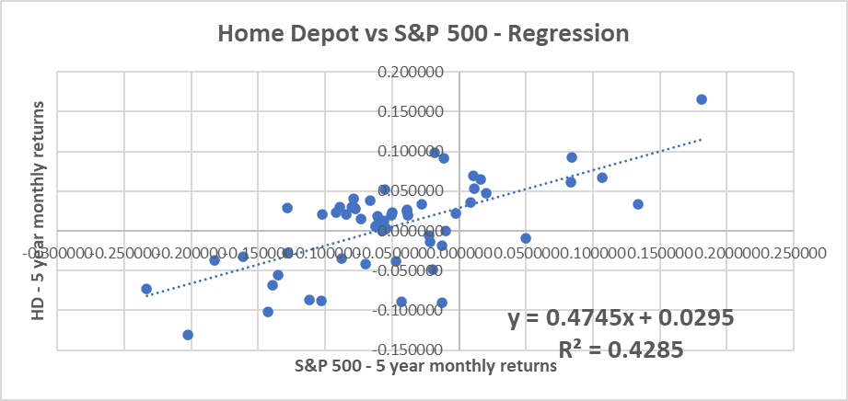

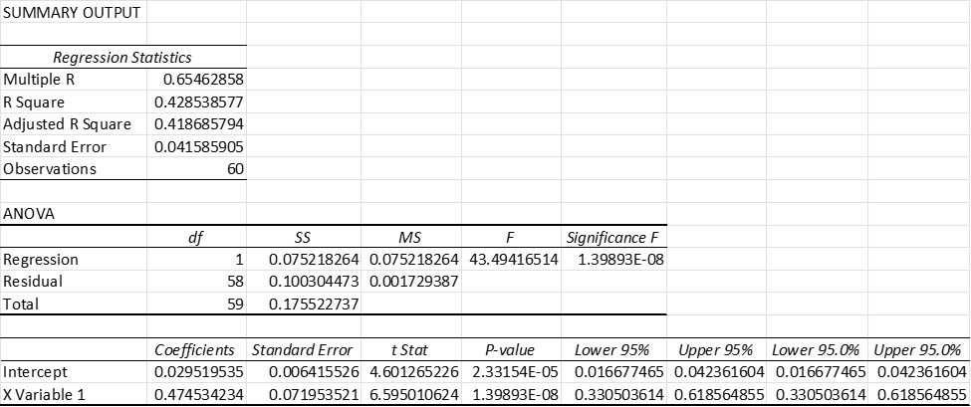

**Appendix 4: Sector vs Index Regression**

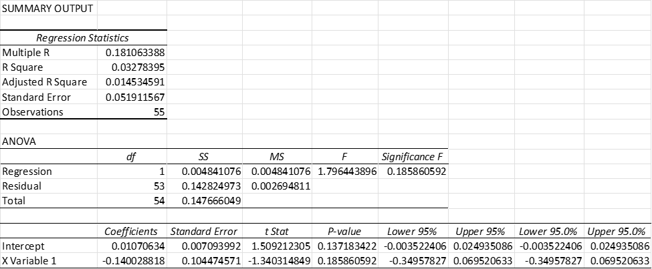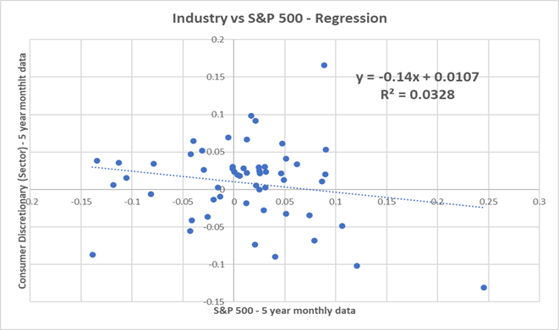

**Appendix 5: Performance of Equity**

|  |  |  |
| --- | --- | --- |
| Year | ROE | Cost of Equity |
| 2021 | 782.14% | 6.98% |

**Appendix 6: Provision for Income Taxes**

|  |
| --- |
| **Taxes for Year ended Jan 31, 2022: amount in millions** |
| Federal $ 4,066 |
| State 981 |
| Foreign 511 |
| Total current 5,558 |
| **Deferred:** |
| Federal (155) |
| State (11) |
| Foreign (88) |
| Total deferred (254) |
| Provision for income taxes **$ 5,304** |
|  |

**Appendix 7: Optimal Debt ratio**

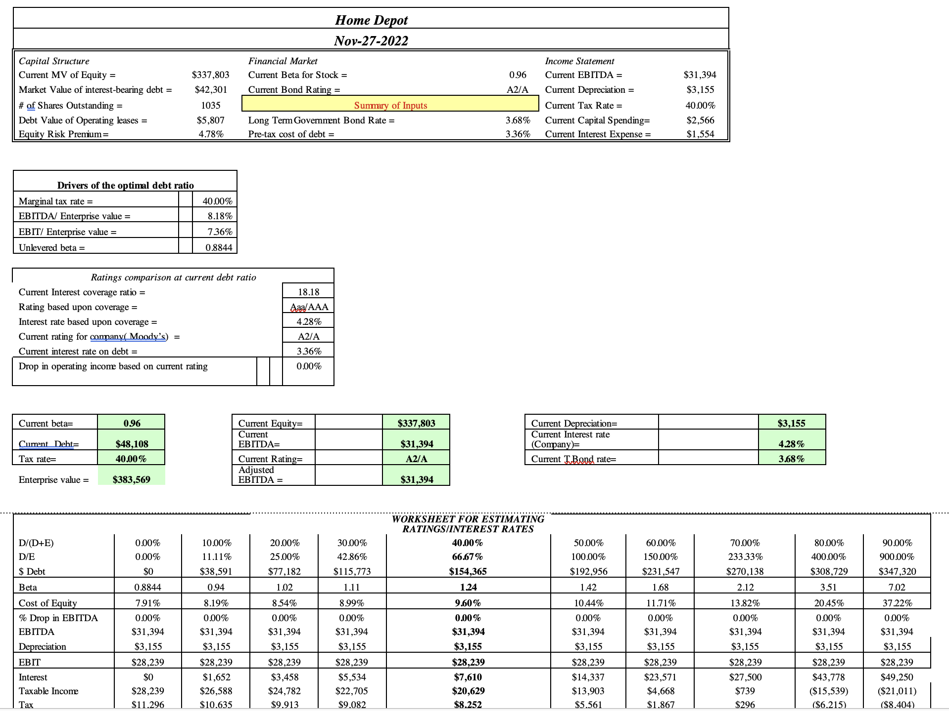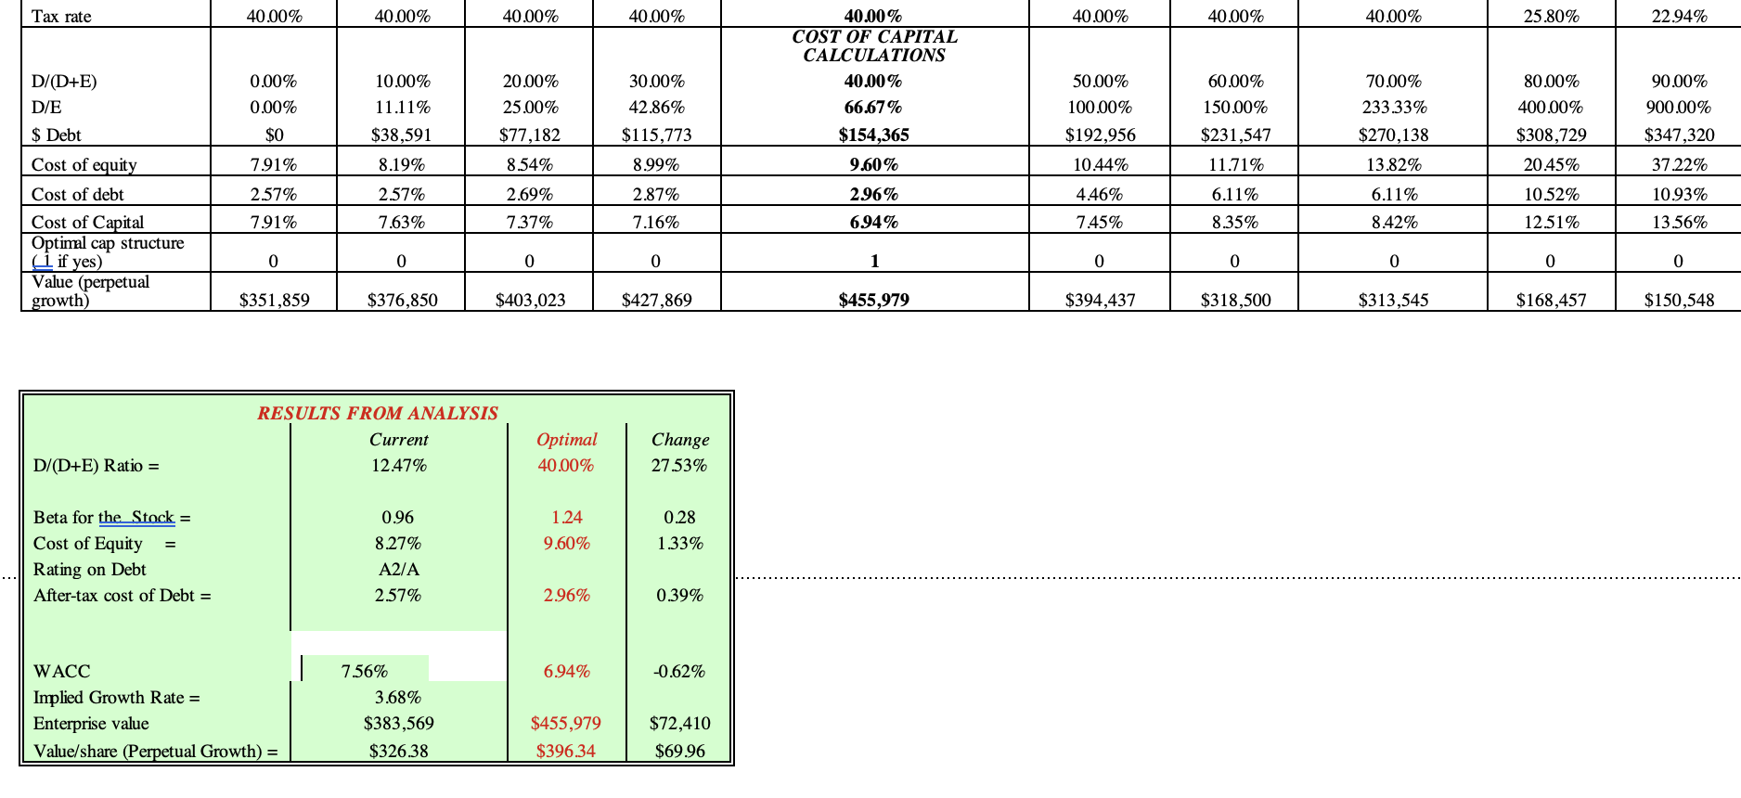

Appendix 8: Relative Evaluation

|  |  |  |
| --- | --- | --- |
| Company Name | Expected Growth Rate | P/E Ratio |
| Home Depot HD | 3.5 | 19.32 |
| Lowe’s Companies, Inc. LOW | 9.9 | 20.21 |
| Walmart Inc. WMT | 19.2 | 47.28 |
| Costco Wholesale Corporation COST | 9.0 | 40.57 |
| Floor & Décor Holdings, Inc. | 16.7 | 27.79 |
| Industry Average | 11.66 | 31.03 |

Appendix 9: Valuation Comparison

|  |  |  |  |
| --- | --- | --- | --- |
|  | DDM | Relative Valuation | Market |
| Value of Share | $100.79 | $406.14 | $318.02 (November 28) |

1. Home Depot Board of Directors, https://ir.homedepot.com/corporate-governance/board-of-directors
2. <https://ca.finance.yahoo.com/news/home-depots-nyse-hd-ceo-135442053.html>
3. https://ir.homedepot.com/corporate-governance/overview
4. https://finance.yahoo.com/quote/HD/holders?p=HD (Oct 16, 2022)
5. https://corporate.homedepot.com/page/responsibility
6. https://corporate.homedepot.com/page/serving-veterans
7. Macrotrends, https://www.macrotrends.net/stocks/charts/HD/home-depot/shares-outstanding
8. Yahoo Finance
9. NASDAQ, https://www.nasdaq.com/articles/what-kind-of-shareholders-own-the-home-depot-inc.-nyse:hd
10. The Home Depot, Inc. Corporate Office Headquarters Contacts &amp; Public Commentary. (n.d.). Retrieved November 29, 2022, from https://www.corporate-office-headquarters.com/the-home-depot-inc
11. Abukari, K. (2022). Lectures 2 and 3 Risk Measurement and the Determination of Hurdle rates in Practice. Finance, Carleton University.
12. The Home Depot. (2022, March 23). ANNUAL REPORT 2021. The Home Depot. Retrieved November 29, 2022, from https://ir.homedepot.com/
13. 10-year Treasury Rate. Y Charts. (n.d.). Retrieved November 29, 2022, from https://ycharts.com/indicators/10_year_treasury_rate#:~:text=Historically%2C%20the%2010%20Year%20treasury,long%20term%20average%20of%204.26%25.
14. Yahoo! (2022, November 29). The Home Depot, Inc. (HD) valuation measures &amp; financial statistics. Yahoo! Finance. Retrieved November 29, 2022, from https://finance.yahoo.com/quote/hd/key-statistics/
15. Home Depot shares outstanding 2010-2022: HD. Macrotrends. (n.d.). Retrieved November 29, 2022, from https://www.macrotrends.net/stocks/charts/HD/home-depot/shares-outstanding#:~:text=Home%20Depot%20shares%20outstanding%20for,a%201.73%25%20decline%20from%202020.
16. Yahoo! (2022, November 29). The Home Depot, Inc. (HD) stock price, news, Quote &amp; History. Yahoo! Finance. Retrieved November 29, 2022, from https://ca.finance.yahoo.com/quote/HD?p=HD&amp;.tsrc=fin-srch
17. An Investment Analysis Case Study: The Home Depot. (2018, March 29). Retrieved November 29, 2022, from https://pages.stern.nyu.edu/~adamodar/pdfiles/cfexams/HDCase.pdf
18. Journal, W. S. (n.d.). HD | Home Depot Inc. annual income statement - WSJ. The Wall Street Journal. Retrieved November 29, 2022, from https://www.wsj.com/market-data/quotes/HD/financials/annual/income-statement
19. Abukari, K. (2022). Lectures 2 and 3 Risk Measurement and the Determination of Hurdle rates in Practice. Finance, Carleton University.
20. Atkins, J. (2021, January 4). Hg bonds: Home Depot prints $3B deal in 3 parts for post-M&A liquidity; terms. Retrieved November 29, 2022, from https://www.spglobal.com/marketintelligence/en/news-insights/latest-news-headlines/hg-bonds-home-depot-prints-3b-deal-in-3-parts-for-post-m-a-liquidity-terms-61962716
21. Atkins, J. (2021, January 4). Hg bonds: Home Depot prints $3B deal in 3 parts for post-M&A liquidity; terms. Retrieved November 29, 2022, from https://www.spglobal.com/marketintelligence/en/news-insights/latest-news-headlines/hg-bonds-home-depot-prints-3b-deal-in-3-parts-for-post-m-a-liquidity-terms-61962716
22. Atkins, J. (2021, January 4). Hg bonds: Home Depot prints $3B deal in 3 parts for post-M&A liquidity; terms. Retrieved November 29, 2022, from https://www.spglobal.com/marketintelligence/en/news-insights/latest-news-headlines/hg-bonds-home-depot-prints-3b-deal-in-3-parts-for-post-m-a-liquidity-terms-61962716
23. 10-year Treasury Rate. Y Charts. (n.d.). Retrieved November 29, 2022, from https://ycharts.com/indicators/10_year_treasury_rate#:~:text=Historically%2C%20the%2010%20Year%20treasury,long%20term%20average%20of%204.26%25.
24. Statista Research Department. (2022, July 4). Average market risk premium in the U.S. 2011-2022. Statista. Retrieved November 29, 2022, from https://www.statista.com/statistics/664840/average-market-risk-premium-usa/#:~:text=The%20average%20market%20risk%20premium,and%205.7%20percent%20since%202011.
25. Letter to shareholders. (. Edward P. Decker). November 29, 2022, from https://ir.homedepot.com/
26. Investor relations. (Edward P. Decker.). November 29, 2022, from https://ir.homedepot.com/
27. 2021 Home Depot Annual 10-k report
28. Appendix 7, calculated using amounts on the financial statement 
29. https://www.sec.gov/Archives/edgar/data/354950/000119312522243713/d377522d424b2.htm
30. https://ycharts.com/indicators/10_year_treasury_rate
31. 2021 Home Depot Annual 10-k report
32. Annual 2021 10-k
33. Appendix 7
34. Yahoo finance
35. https://finbox.com/FINBOX:HD/explorer/altman_z_score
36. *https://www.macrotrends.net/stocks/charts/HD/home-depot/shares-outstanding* 
37. *https://www.macrotrends.net/stocks/charts/HD/home-depot/shares-outstanding* 
38. *https://www.macrotrends.net/stocks/charts/HD/home-depot/shares-outstanding* 
39. Appendix 7
40. https://csimarket.com/Industry/industry_Financial_Strength_Ratios.php?s=400
41. The Home Depot. (2022, March 23). ANNUAL REPORT 2021. The Home Depot. Retrieved November 29, 2022, from https://ir.homedepot.com/
42. The Home Depot. (2022, March 23). ANNUAL REPORT 2021. The Home Depot. Retrieved November 29, 2022, from https://ir.homedepot.com/
43. The Home Depot. (2022, March 23). ANNUAL REPORT 2021. The Home Depot. Retrieved November 29, 2022, from https://ir.homedepot.com/
44. Abukari, K. (2022). Lecture 10 Returning Cash to the Owners: Dividend Policy. Finance, Carleton University.
45. Dividend history. The Home Depot. (n.d.). Retrieved November 29, 2022, from https://ir.homedepot.com/stock-information/dividend-history
46. The Home Depot. (2022, March 23). ANNUAL REPORT 2021. The Home Depot. Retrieved November 29, 2022, from https://ir.homedepot.com/
47. Yahoo! (2022, November 29). The Home Depot, Inc. (HD) stock price, news, Quote &amp; History. Yahoo! Finance. Retrieved November 29, 2022, from https://ca.finance.yahoo.com/quote/HD?p=HD&amp;.tsrc=fin-srch
48. Abukari, K. (2022). Lecture 10 Returning Cash to the Owners: Dividend Policy. Finance, Carleton University.
49. Simply Wall St. (2022, October 6). The Home Depot, Inc. (NYSE: HD) is a favorite amongst institutional investors who own 70%. Simply Wall St News. Retrieved November 29, 2022, from https://simplywall.st/stocks/us/retail/nyse-hd/home-depot/news/the-home-depot-inc-nysehd-is-a-favorite-amongst-institutiona
50. Jain, R. (2007, May 4). Institutional and individual investor preferences for dividends and share repurchases. Journal of Economics and Business. Retrieved November 29, 2022, from https://www.sciencedirect.com/science/article/abs/pii/S0148619507000392#:~:text=This%20study%20shows%20that%20individual,Thakor.
51. Bourgi, S. (n.d.). Dividend history of the consumer discretionary sector. Dividend.com. Retrieved November 29, 2022, from https://www.dividend.com/how-to-invest/dividend-history-of-the-consumer-discretionary-sector/
52. https://www.cnbc.com/2022/02/22/home-depot-wants-to-win-home-professionals-bigger-orders.html